1. Extract ECM_Setup.zip file in local disk
2. Rename your device certificate as “device_cert.crt” and replace the one in directory ECM_Setup\crypto\certs

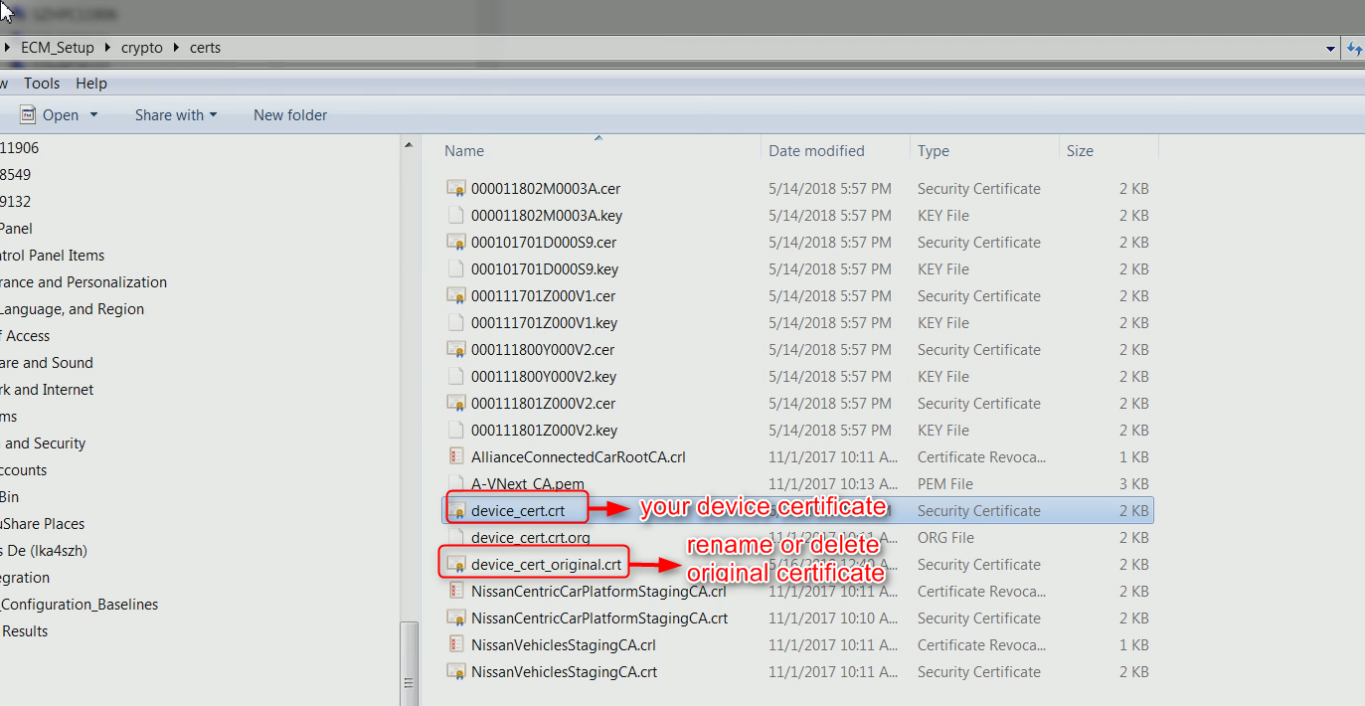

1. Same as step 2, rename your private key as “device_priv_key.pem” and replace the one in directory ECM_Setup\crypto\id

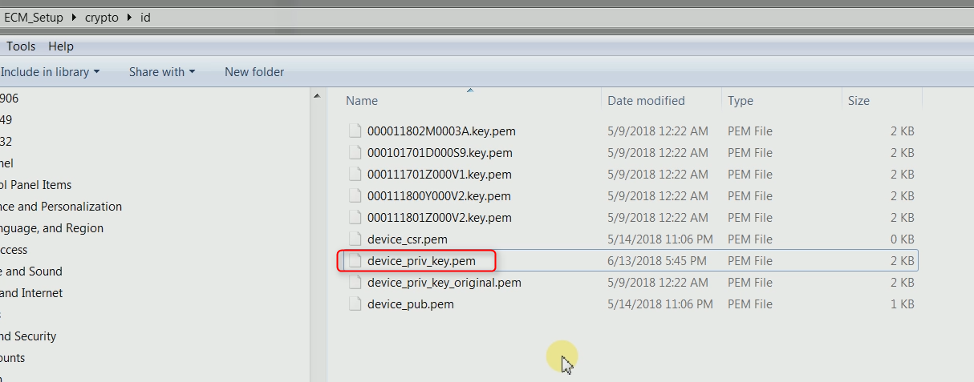

1. Copy the whole ECM_setup to root directory of device

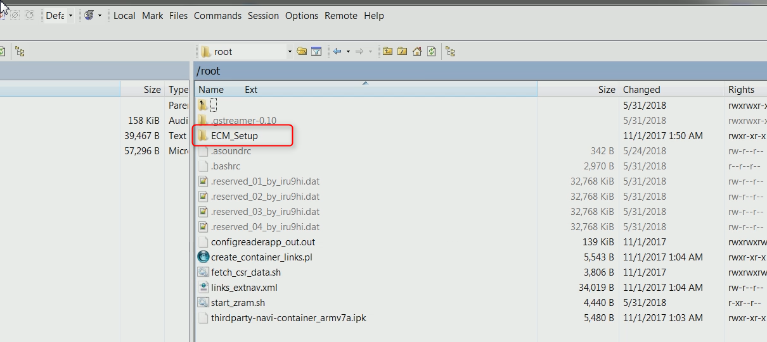

1. Run scripts ECM_Setup/ECM_setup.sh in Putty with your IVI_Id (from device information) as parameter

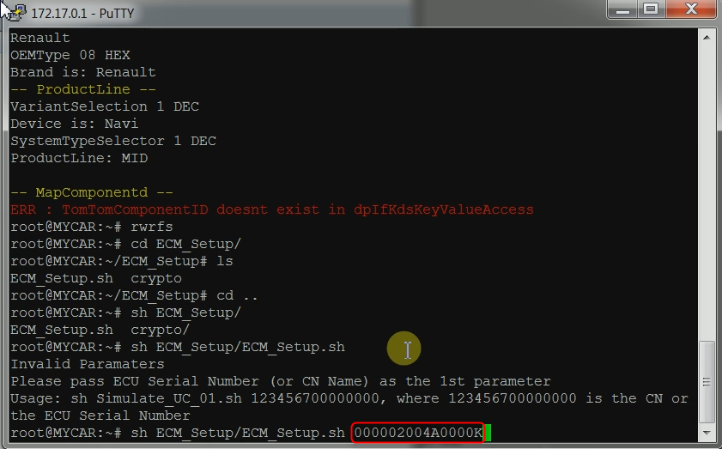

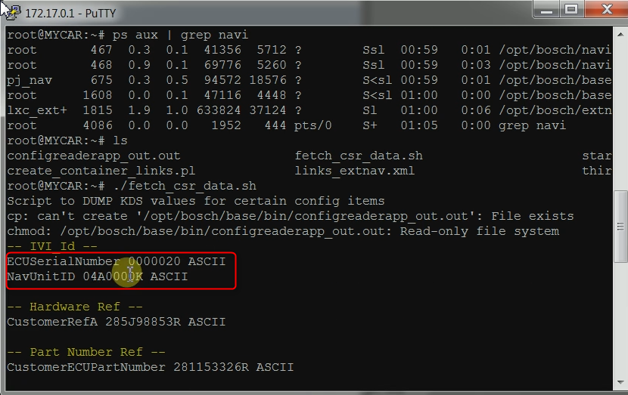

1. After successfully running script, following files will be created on device

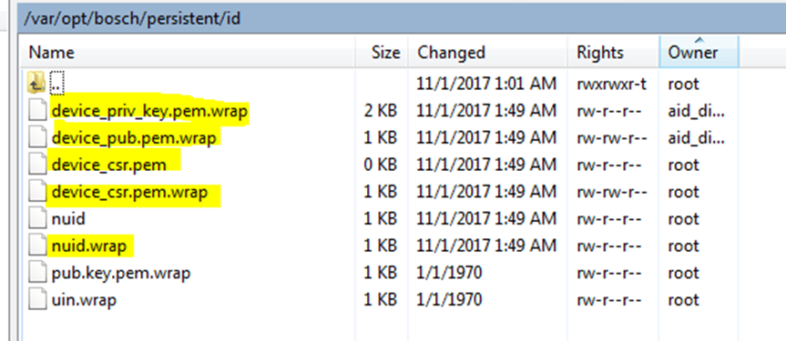

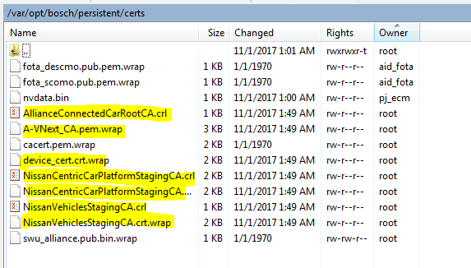

1. Copy “rbcm-certtools_0.5.opk” to root directory of device

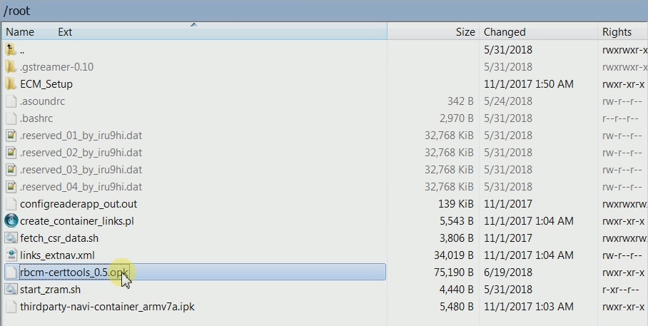

1. Install the .opk in putty with command “opkg install rbcm-certtools_0.5.opk”

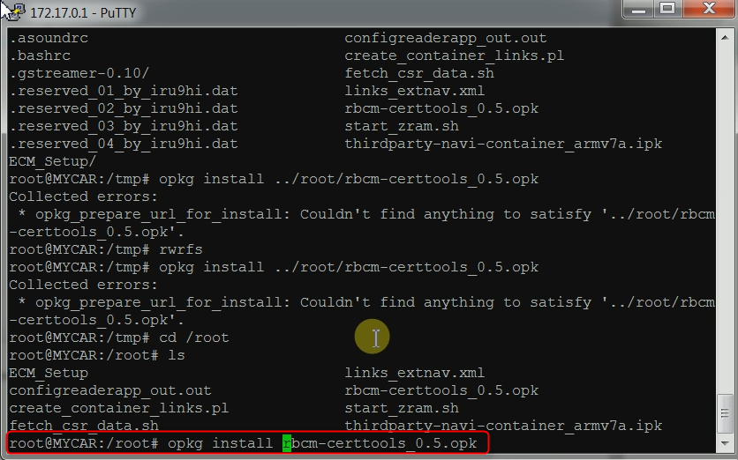

1. After successful installation, run command “sh switch_pa_env.sh -e SIT” to switch environment from STG to SIT

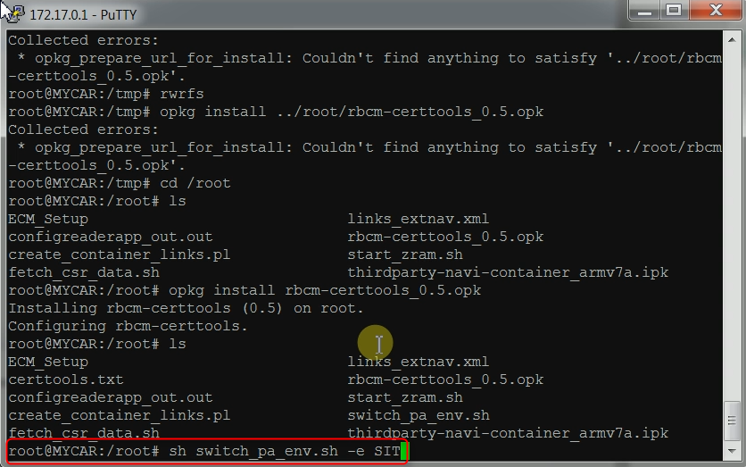

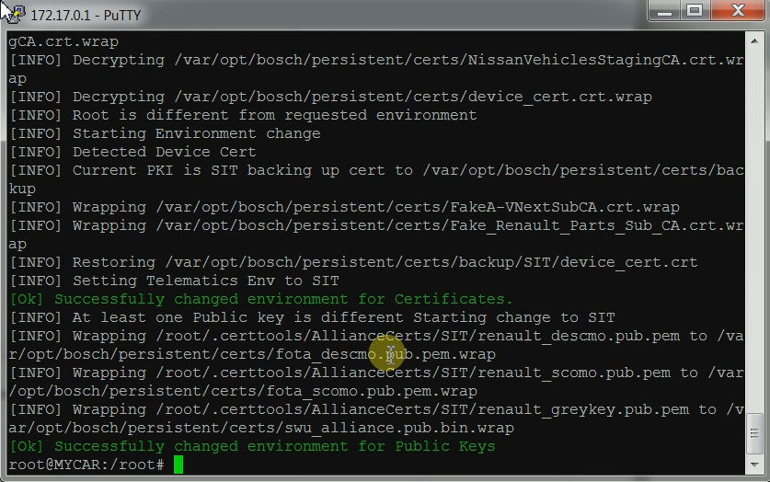

1. Check the files in “var/opt/bosch/persistent/certs/”, you should see Fake Renault .crt files like below figure

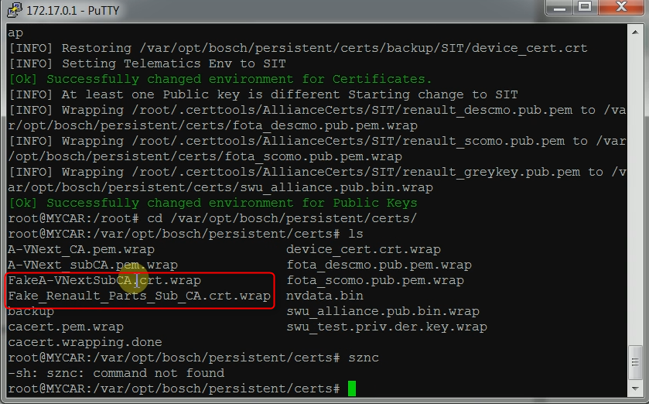

1. Sync and restart ECM service with the two commands in below figure

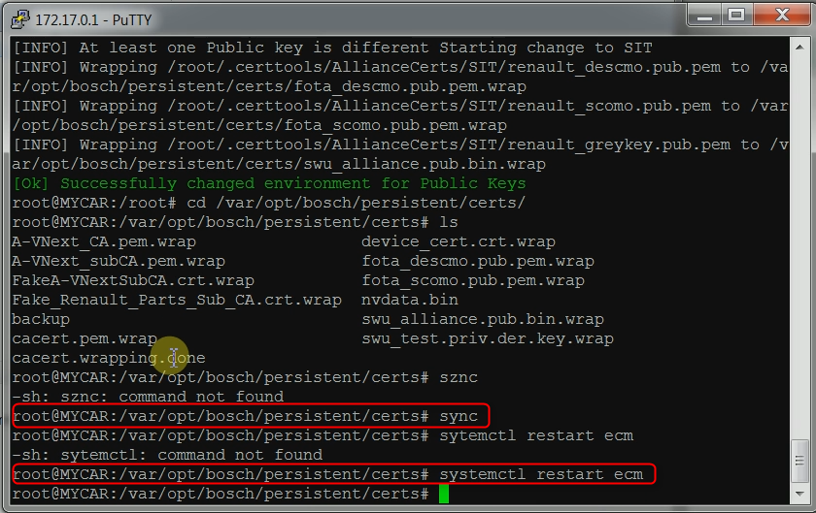

1. Check ECM log with command “cat /tmp/ecm.log”

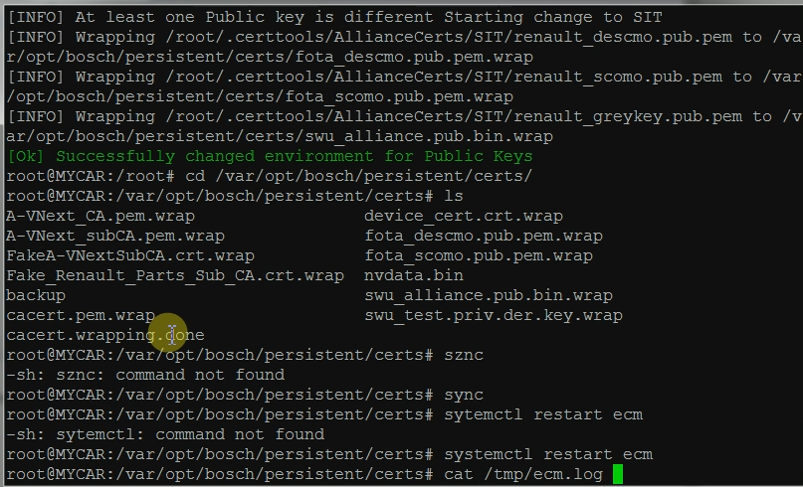

1. If the certificates are installed successfully, the ECM will start up and following info will be seen in log.

